
INCLUSION AND DIVERSITY POLICY
(Includes Equal Opportunity and Sexual Harassment)
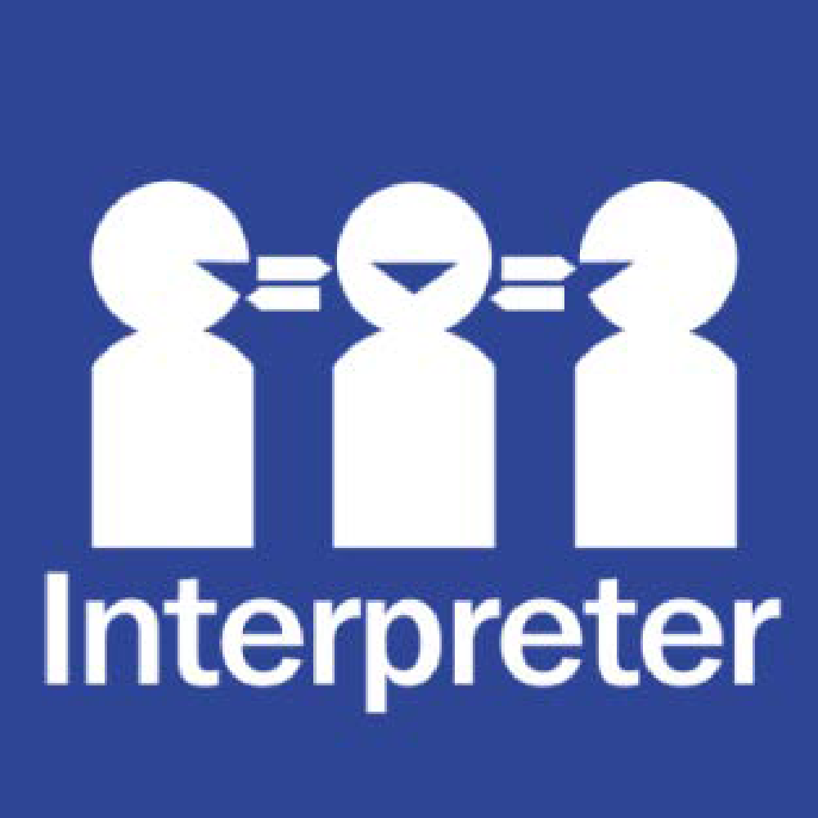
Help for non-English speakers
If you need help to understand the information in this policy, please contact the school office on (03) 9546 9210.

PURPOSE
The purpose of this policy is to explain how Harrisfield Primary Schhol works to make sure every member of our school community is treated with respect and dignity, regardless of their background or personal attributes . This policy should be read alongside the following department policies:
- Equal Opportunity and Human Rights - Students
- For staff, the Respectful Workplaces policies (including Equal Opportunity – Employees, Sexual Harassment – Employees and Workplace Bullying) as these whole of department policies apply to all staff at Harrisfield Primary School.

POLICY

Definitions
Personal attribute: a personal characteristic that is protected by State or Commonwealth anti-discrimination legislation. These include: race, disability, sex, sexual orientation, gender identity, religious belief or activity, political belief or activity, age, intersex status, physical features, pregnancy, carer and parental status, breastfeeding, marital or relationship status, lawful sexual activity, employment activity, industrial activity, expunged homosexual conviction or personal association with anyone who is identified with reference to any protected attribute.
Direct discrimination: unfavourable treatment because of a person’s protected attribute.
Indirect discrimination: imposing an unreasonable requirement, condition or practice that disadvantages a person or group of people with a protected attribute.
Sexual harassment: unwelcome conduct of a sexual nature towards another person which could reasonably be expected to make that other person feel offended, humiliated or intimidated. It may be physical, verbal, visual or written.
Disability harassment: an action taken in relation to the person’s disability that is reasonably likely, in all the circumstances, to humiliate, offend, intimidate or distress the person.
Vilification: conduct that incites hatred towards or revulsion or severe ridicule of a person or group of people on the basis of their race or religion.
Victimisation: subjecting a person or threatening to subject them to detrimental treatment because they (or their associate) has made an allegation of discrimination or harassment on the basis of a protected attribute (or asserted their rights under relevant policies or law).

Inclusion and diversity
Harrisfield Primary School strives to provide a safe, inclusive and supportive school environment which values the human rights of all students and staff.
Harrisfield Primary School is committed to creating a school community where all members of our school community are welcomed, accepted and treated equitably and with respect regardless of their backgrounds or personal attributes such as race, language, religious beliefs, gender identity, disability or sexual orientation so that they can participate, achieve and thrive at school.
Harrisfield Primary School acknowledges and celebrates the diversity of backgrounds and experiences in our school community, and we do not tolerate behaviours, language or practices that label, stereotype or demean others. At Harrisfield Primary School we value the human rights of every student and we take our obligations under anti-discrimination laws and the Charter of Human Rights and Responsibilities seriously.
Harrisfield Primary School:
- actively nurtures and promotes a culture where everyone is treated with respect and dignity
- ensures that students are not discriminated against (directly or indirectly) and where necessary, are reasonably accommodated to participate in their education and school activities (e.g. schools sports, concerts, production, arts fiesta, incursions, excursions and camps) on the same basis as their peers
- acknowledges and responds to the diverse needs, identities and strengths of all students
- encourages empathy and fairness towards others
- challenges stereotypes that promote prejudicial and biased behaviours and practices
- contributes to positive learning, engagement and wellbeing outcomes for students
- responds to complaints and allegations appropriately and ensure that students are not victimised
Bullying, unlawful discrimination, harassment, vilification and other forms of inappropriate behaviour targeting individuals or groups because of their personal attributes is not tolerated at Harrisfield Primary School. We will take appropriate measures, consistent with our Student Wellbeing and Engagement and Bullying policies to respond to students who demonstrate these behaviours at our school.
Students who may have experienced or witnessed this type of behaviour are encouraged to speak up and to let their teachers, parents or carers know about those behaviours to ensure that inappropriate behaviour can be addressed.
Reasonable adjustments for students with disabilities
Harrisfield Primary School also understands that it has a legal obligation to make reasonable adjustments to accommodate students with disabilities. A reasonable adjustment is a measure or action taken to assist students with disabilities to participate in their education on the same basis as their peers in accordance with the department’s Students with Disability Policy. Reasonable adjustments are made for students with disabilities in consultation with the student, their parents or carers, their teachers and if appropriate, their treating practitioners. Our school may consult through Student Support Group processes in consultation with the student, their parents or carers, their teachers and if appropriate, their treating practitioners. For more information about support available for students with disabilities, and communicating with us in relation to a student’s disability, please refer to our school’s Student Wellbeing and Engagement Policy.docxor contact Trish Harry, Principal.
COMMUNICATION
This policy will be communicated to our school community in the following ways:
- Available publicly on our school’s website where applicable
- Saved on staff Google drive
- Included in staff induction processes, staff training and child safety training processes
- Discussed at staff briefings/meetings as required
- Discussed at parent information nights/sessions where applicable
- Included as annual reference as a COMPASS notification if required
- Made available in hard copy from school administration upon request.

RELATED POLICIES AND RESOURCES
For staff, please see the Department’s Equal Opportunity and Anti-Discrimination Policy, Sexual Harassment Policy and Workplace Bullying Policy which apply to all staff working at our school.
Other relevant Department policies and resources on the Department’s Policy and Advisory Library are:
  - Equal Opportunity and Human Rights - Students
  - Students with Disability
  - Koorie Education
  - Teaching Aboriginal and Torres Strait Islander Culture
  - Program for Students with Disabilities

POLICY REVIEW AND APPROVAL
Policy last reviewed | 4th August 2026
Approved by | Principal
Next scheduled review date | August 2029

