
STATEMENT OF VALUES AND
SCHOOL PHILOSOPHY
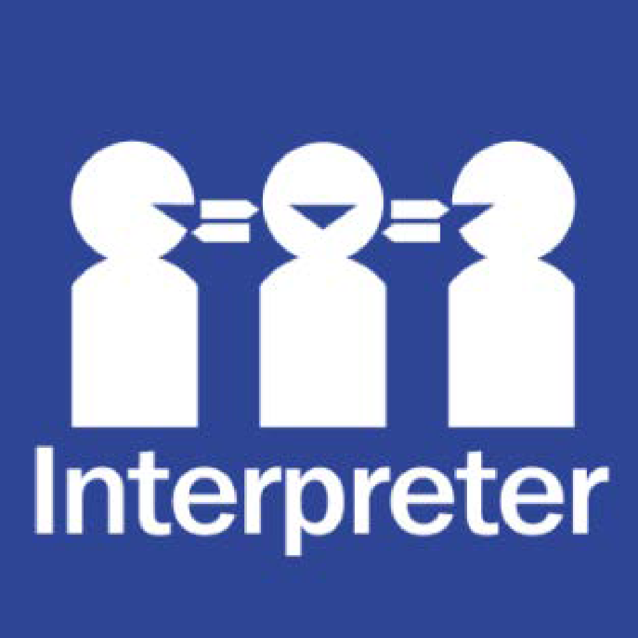
Help for non-English speakers
If you need help to understand the information in this policy, please contact the school office on (03) 9546 9210.

PURPOSE
The purpose of this policy is to outline the values of our school community and explain the vision, mission and objectives of our school.

POLICY
Harrisfield Primary School is committed to providing a safe, supportive and inclusive environment for all students, staff and members of our community. Our school recognises the importance of the partnership between our school and parents and carers to support student learning, engagement and wellbeing. We share a commitment to, and a responsibility for, creating an inclusive and safe school environment for our students.
The programs and teaching at Harrisfield Primary School support and promote the principles and practice of Australian democracy, including a commitment to:
- elected government
- the rule of law
- equal rights for all before the law
- freedom of religion
- freedom of speech and association
- the values of openness and tolerance.
This policy outlines our school’s vision, mission, objective, values and expectations of our school community.
To celebrate and embed our Statement of Values and Philosophy in our school community, we
- display posters and banners that promote our values in our school
- provide awards and recognition for students who actively demonstrate the values: ACE Awards
- discuss our values with students in the classroom, meetings and assemblies.

VISION
Harrisfield Primary School strives to develop the personal and interpersonal skills of every student to enable them to become active participants of their global community. Our contribution to their learning journey will build the foundations for them to be innovative thinkers and life-long learners, prepared to face the challenges of an ever changing society.

MISSION
To provide a secure, caring and harmonious learning environment which provides every student with the opportunity to experience success.

OBJECTIVE
Harrisfield Primary School’s objective is to maximise each student’s potential to achieve academic and social success, whilst celebrating and embracing diversity.

VALUES
As a school community we all agree to engender trust and respect between all members of the school community through Agreement, Communication and Equity.
The school values are:
Agreement
Communication
Equity
Please refer to ACE Values document at the bottom of this policy.

BEHAVIOURAL EXPECTATIONS
Harrisfield Primary School acknowledges that the behaviour of staff, parents, carers and students has an impact on our school community and culture.
Staff have a range of expectations around behaviour and must follow our school and Department policies and the Victorian Public Service Code of Conduct and Values. Teaching staff also adhere to the Victorian Teaching Profession Code of Conduct.
Students are supported by school staff to meet expected standards of behaviour as outlined in our Student Wellbeing and Engagement Policy, Inclusion and Diversity Policy, Bullying Prevention Policy etc.
Information about the expectations on parents and carers to ensure schools remain respectful and inclusive places is outlined in our Respect for School Staff Policy.
Harrisfield Primary School acknowledges that the behaviour of staff, parents, carers and students has an impact on our school community and culture. We acknowledge a shared responsibility to create a positive learning environment for the children and young people at our school.
As Principals and school leaders, we will:
- model positive behaviour and effective leadership
- communicate politely and respectfully with all members of the school community
- work collaboratively to create a school environment where respectful and safe behaviour is expected of everyone
- behave in a manner consistent with the standards of our profession and meet core responsibilities to provide safe and inclusive environments
- plan, implement and review our work to ensure the care, safety, security and general wellbeing of all students at school
- identify and support students who are or may be at risk
- do our best to ensure every child achieves their personal and learning potential
- work with parents to understand their child’s needs and, where necessary, adapt the learning environment accordingly
- respond appropriately when safe and inclusive behaviour is not demonstrated and implement appropriate interventions and sanctions when required
- inform parents of the school’s communication and complaints procedures
- ask any person who is acting in an offensive, intimidating or otherwise inappropriate way to leave the school grounds.

As teachers and non-teaching school staff, we will:
- model positive behaviour to students consistent with the standards of our profession
- communicate politely and respectfully with all members of the school community
- proactively engage with parents about student outcomes
- work with parents to understand the needs of each student and, where necessary, adapt the learning environment accordingly
- work collaboratively with parents to improve learning and wellbeing outcomes for students with additional needs
- communicate with the Principal and school leaders in the event we anticipate or face any tension or challenging behaviours from parents
- treat all members of the school community with respect.

As parents and carers, we will:
- model positive behaviour to our child
- communicate politely and respectfully with all members of the school community, in line with our Respect for School Staff Policy
- ensure our child attends school on time, every day the school is open for instruction
- take an interest in our child’s school and learning
- work with the school to achieve the best outcomes for our child
- communicate constructively with the school and use expected processes and protocols when raising concerns
- support school staff to maintain a safe learning environment for all students
- follow the school’s processes for communication with staff and making complaints
- treat all school leaders, staff, students, and other members of the school community with respect.

As students, we will:
- model positive behaviour to other students
- communicate politely and respectfully with all members of the school community
- comply with and model school values
- behave in a safe and responsible manner
- respect ourselves, other members of the school community and the school environment
- actively participate in school
- not disrupt the learning of others and make the most of our educational opportunities.

As community members, we will:
- model positive behaviour to the school community
- treat other members of the school community with respect
- support school staff to maintain a safe and inclusive learning environment for all students
- utilise the school’s processes for communication with staff and submitting complaints.

UNREASONABLE BEHAVIOURS
Schools are not public places, and the Principal has the right to permit or deny entry to school grounds (for more information, see our Visitors Policy).
Unreasonable behaviour that is demonstrated by school staff, parents, carers, students or members of our school community will not be tolerated at school, or during school activities.
Unreasonable behaviour includes:
- being violent or threatening violence of any kind, including physically intimidating behaviour such as aggressive hand gestures or invading another person’s personal space
- speaking or behaving in a rude, aggressive or threatening way, either in person, via email, social media, or over the telephone
- sending demanding, rude, confronting or threatening letters, emails or text messages
- discriminatory or derogatory comments
- the use of social media or public forums to make inappropriate or threatening remarks about the school, staff or students.

Harassment, bullying, violence, aggression, threatening behaviour and unlawful discrimination are unacceptable and will not be tolerated at our school.

Unreasonable behaviour and/or failure to uphold the principles of this Statement of Values and School Philosophy may lead to further investigation and the implementation of appropriate consequences by the school Principal.
At the Principal’s discretion, unreasonable behaviour may be managed by:
- requesting that the parties attend a mediation or counselling sessions
- implementing specific communication protocols
- written warnings
- conditions of entry to school grounds or school activities
- exclusion from school grounds or attendance at school activities
- reports to Victoria Police
- legal action.

Inappropriate student behaviour will be managed in according with our school’s Student Wellbeing and Engagement Policy and Bullying Prevention Policy.

Our Statement of Values and School Philosophy ensures that everyone in our school community will be treated with fairness and respect. In turn, we will strive to create a school that is inclusive and safe, where everyone is empowered to participate and learn.

This policy forms a critical component of ensuring that Harrisfield Primary School is a Child Safe School.

COMMUNICATION
This policy will be communicated to our school community in the following ways:
- Available publicly on our school’s website where applicable
- Saved on Google drive
- Included in staff induction processes, staff training and child safety training processes
- Discussed at staff briefings/meetings as required
- Discussed at parent information nights/sessions where applicable
- Included as annual reference as a COMPASS notification if required
- Made available in hard copy from school administration upon request.

RELATED POLICIES AND RESOURCES
Department of Education and Training policies and resources:
- Work-Related Violence in Schools Policy
- Respectful Behaviours within the School Community Policy
Harrisfield Primary School polices:
- Student Wellbeing and Engagement Policy
- Inclusion and Diversity Policy
- Bullying Prevention Policy
- Complaints Policy

POLICY REVIEW AND APPROVAL

Policy last reviewed | 8th August 2024
Approved by | School Council: Meeting 19th August 2024
Next scheduled review date | August 2027

