
RESPECT FOR SCHOOL STAFF POLICY

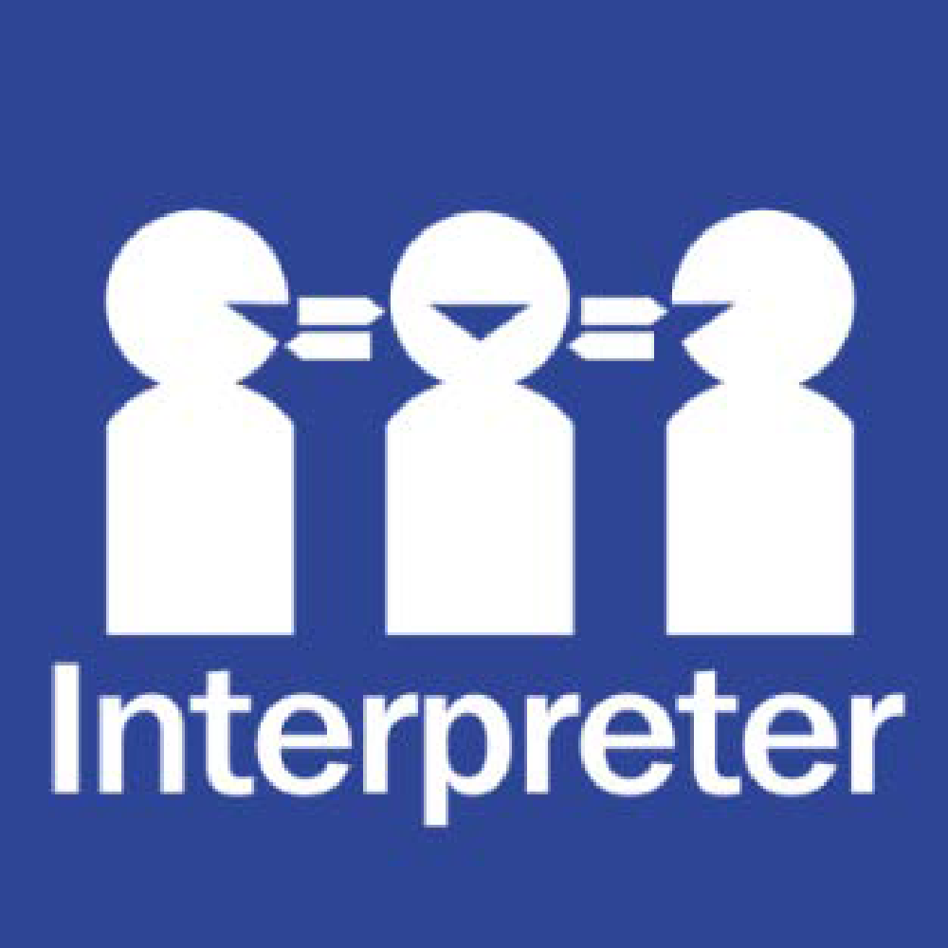
Help for non-English speakers
If you need help to understand the information in this policy, please contact the school office on (03) 9546 9210.

PURPOSE
To ensure that members of our community understand Harrisfield Primary School’s expectations for appropriate interactions with school staff.

POLICY
Staff at Harrisfield Primary School, including teachers, education support staff, office staff, the Assistant Principal/s and Principal are committed to providing a positive and supportive learning environment for all our students. Our staff take their work very seriously and feel privileged to be able to play an important role in each child’s education.
Parents/carers and visitors to our school also have an important role to play in fostering a safe and inclusive environment for the entire school community.

Respectful behaviours within the school community
All staff at Harrisfield Primary School have a right to a safe and supportive work environment, and we expect that parents/carers and visitors behave in an appropriate and respectful manner at all times.

The Department of Education and Training has outlined expectations on parent/carer behaviour within Victorian government school communities in the Respectful Behaviours within the School Community Policy.

Unacceptable behaviours
When parents and carers engage in unacceptable behaviours against a staff member or another member of the school community, this can affect their health, safety and wellbeing.
Unacceptable behaviours include, but are not limited to:
- being violent or threatening violence of any kind, including physically intimidating behaviour such as aggressive hand gestures or invading another person’s personal space
- speaking or behaving in a rude, aggressive or threatening way, either in person, via email, social media, or over the telephone
- sending demanding, rude, confronting or threatening letters, emails or text messages
- discriminatory or derogatory comments
- the use of social media or public forums to make inappropriate or threatening remarks about the school, staff or students.

At the Principal’s discretion, unacceptable behaviour may be managed by:
- requesting that the parties attend a mediation or counselling sessions
- implementing specific communication protocols
- written warnings
- conditions of entry to school grounds or school activities
- exclusion from school grounds or attendance at school activities
- reports to Victoria Police
- legal action.

The Principal may also seek support from Department of Education and Training staff when managing unacceptable parent or carer behaviour.
Respectfully raising complaints
We welcome complaints from parents and carers if they are communicated in a respectful and constructive way. Complaints and concerns raised with us can help our school community by providing feedback to improve how our school operates.
When raising a complaint or concern with us, Harrisfield Primary School expects all members of our community to act consistently with this policy, our Statement of Values and School Philosophy and the Department’s Respectful Behaviours within the School Community Policy.
For information on how to raise a complaint or concern with our school, refer to our Harrisfield Primary School Parent Complaints Policy.
The Family Engagement in Learning is also a useful Department resource outlining how parents and carers can best engage with schools to provide feedback, suggestions and complaints.
COMMUNICATION
This policy will be communicated to our school community in the following ways:
- Available publicly on our school’s website where applicable
- Saved on Google drive
- Included in staff induction processes, staff training and child safety training processes
- Discussed at staff briefings/meetings as required
- Discussed at parent information nights/sessions where applicable
- Included as annual reference as a COMPASS notification if required
- Made available in hard copy from school administration upon request.

RELATED POLICIES AND RESOURCES
Department of Education and Training policies and resources:
- Work-Related Violence in Schools Policy
- Respectful Behaviours within the School Community Policy
- Family engagement in learning
Harrisfield Primary School polices:
- Parent Complaints Policy
- Statement of Values and School Philosophy
POLICY REVIEW AND APPROVAL
Policy last reviewed | 16th May 2024
Approved by | Principal
Next scheduled review date | May 2027

