
PHOTOGRAPHING, FILMING AND RECORDING STUDENTS POLICY
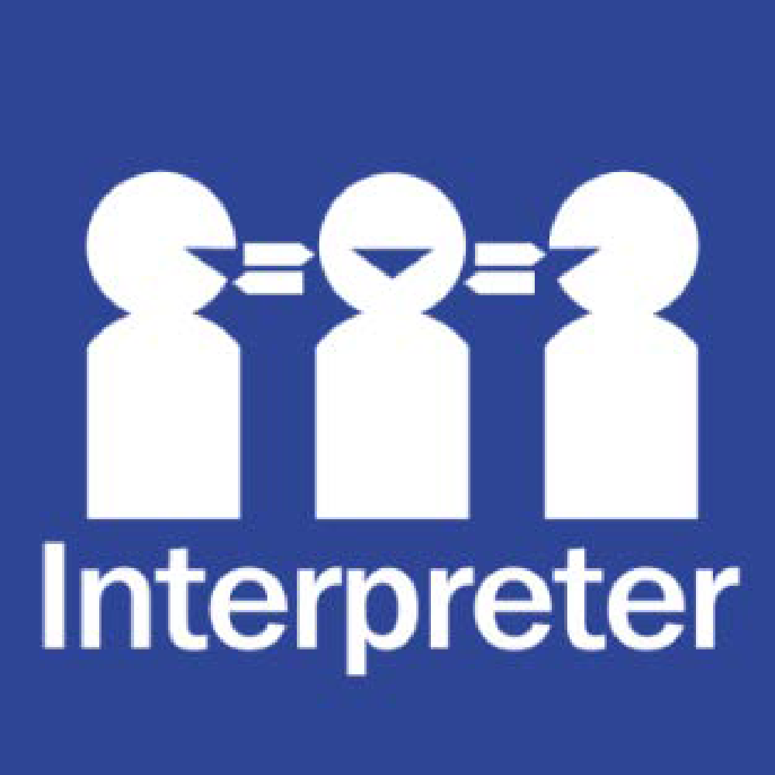
Help for non-English speakers
If you need help to understand the information in this policy, please contact the school office on (03) 9546 9210.

PURPOSE
To explain to parents/carers:
- how Harrisfield Primary School collects, uses and discloses photographs, video and recordings of students
- when parent/carer consent is required before photographing, filming and recording students
- how consent can be provided and withdrawn.
SCOPE
This policy applies to the general collection, use and disclosure of photographs, video and recordings (images) of students.
The policy does not cover the:
- use of Closed-Circuit Television (CCTV). The use of CCTV is covered in the department’s CCTV in Schools Policy.
- use and disclosure of photographs, video and recordings of adults.
POLICY
There are many occasions during the school year where Harrisfield Primary School staff photograph, film or record students participating in school activities or events, for example: classroom activities, sports events, concerts, production, Arts Fiesta, Art Show excursions, camps etc.
We do this for many reasons including to celebrate student participation and achievement, showcase learning programs, document a student’s learning journey/camps/excursions/sports events, communicate with our parents/carers and school community on COMPASS and on classroom blogs/apps/etc. There may also be occasions where we take images to support student behaviour management or to fulfil legal obligations. Further detail is provided within this policy.
In addition to the above, there may be situations where a third party requests to take, use or disclose images of students.
This policy outlines the practices that Harrisfield Primary School has in place for the collection, use and disclosure of images of students to ensure compliance with the Privacy and Data Protection Act 2014 (Vic). It also explains the circumstances in which we will seek parent/carer consent and how consent can be provided and withdrawn.
CONSENT
The Photographing, Filming and Recording Students Consent Form is provided by Harrisfield Primary School at enrolment. This form applies to standard uses of images for the time your child attends the school. Standard uses are defined in the following sections.
For non-standard uses, where consent is required, parents/carers will be sent a consent form for that specific situation. Schools will also notify parents when implementing software that may include photos of students, giving parents an opportunity to discuss any concerns or preferences.
If at any time parents/carers wish to withdraw their consent, they can by contacting the school office on (03) 9546 9210. If consent is withdrawn verbally, the school will make a written record of this. However:
- if the images have already been published and are in the public domain, it may not be possible to remove them
- the school can still collect, use and disclose images in circumstances where consent is not required (see below for more information).
IMAGE USE WITHIN THE PHYSICAL SCHOOL ENVIRONMENT
Harrisfield Primary School may photograph, film or record students to use within the physical school environment, including:
- for display in school classrooms e.g. in displays of student work, on noticeboards to celebrate achievements
A Photographing, Filming and Recording Students Consent Form will be given to parents/carers on enrolment for the standard uses described above. Consent, if given, applies until it is withdrawn or changed. If a parent/carer would like to withdraw or change their consent at any point in time, they must notify the school.
IMAGE USE WITHIN THE SCHOOL COMMUNITY
Harrisfield Primary School may photograph, film or record students to use within the school community, including:
- in the school’s online communication, learning and teaching tools e.g., emails, classroom blogs or apps that can only be accessed by students, parents/carers and school staff with passwords.
- in the school’s communication via COMPASS.
A Photographing, Filming and Recording Students Consent Form will be given to parents/carers on enrolment for the standard uses described above. Consent, if given, applies until it is withdrawn or changed. If a parent/carer would like to withdraw or change their consent at any point in time, they must notify the school.
MEDIA
The media, or the Department of Education’s media team, may seek to photograph, film or record students for a news story or school event. This may include broadcast media, online or social media or print media, including newspapers and magazine publications.
When Harrisfield Primary School receives such requests, our school will:
- provide parents/carers with information about the organisation involved and when and for what purposes the photography, filming or recording will occur
- seek prior, express parent/carer consent in writing.
Students will only be photographed, filmed or recorded by the media at school if express consent is provided for that specific media event. Neither the school nor the department own or control any photographs, video or recordings of students taken by the media.
RESEARCH
On occasion, the school may agree to research projects being conducted at the school. If this occurs, parent/carer consent will be sought for student participation, including any photography or recording of students.
CLOSED CIRCUIT TELEVISION (CCTV)
Our school's CCTV system is managed in accordance with the department's CCTV Installation and Management Policy. Further information about how CCTV is managed and operated is available in our CCTV Privacy Notice.]
OTHER EXTERNAL COLLECTION, USE OR DISCLOSURE
If there is a situation which will involve the collection, use or disclosure of images of students by or to third parties which is not otherwise covered by this policy, Harrisfield Primary School will:
- provide parents/carers with information about the event or activity, the organisation involved and when the photography, filming or recording will occur
- seek prior, express parent/carer consent in writing.
OFFICIAL SCHOOL PHOTOGRAPHS
Each year Harrisfield Primary School will arrange for a professional photographer to take official school photographs of students. This will generally involve both class photos and individual photos being taken.
Official school photographs may be:
- purchased by parents/carers
- used for school identification cards and student identity verification letters
- stored on CASES21 & COMPASS for educational and administrative purposes.
Harrisfield Primary School will notify parents/carers in advance of the official school photographs being taken to give them an opportunity to decide whether their child will be included in the photographs.
Parents/carers who choose to opt out of having their child participate in official school photographs must contact the office on (03) 9546 9210 before the date photos are scheduled to be taken to advise that their child will not participate. There is no obligation on any parent or carer to purchase any photographs taken. However, the school will need to discuss with these parents/carers alternative arrangements for identifying students in emergencies and for other essential purposes.
IMAGES TO MANAGE STUDENT BEHAVIOUR OR FULFIL OUR SCHOOL’S LEGAL OBLIGATIONS, INCLUDING CHILD SAFETY
On occasion, it may be necessary for school staff to photograph, film or record students and/or use images to:
- fulfil legal obligations, including to:
  - take reasonable steps to reduce the risk of reasonably foreseeable harm to students, staff and visitors (duty of care)
  - provide a safe and suitable workplace (occupational health and safety law)
  - supporting students’ social and emotional wellbeing, and health (duty of care)
- for identification purposes, when necessary to implement discipline and/or behaviour management policies.
Harrisfield Primary School does not require or obtain consent from parents/carers or students to photograph, film or record students, or to use these images, for these reasons. However, when Harrisfield Primary School photographs, films or records a student for any of these purposes, staff will only collect and use such images in a way that is necessary, reasonable and appropriate in the circumstances.
CHILD SAFE STANDARDS
Harrisfield Primary School will use student images reasonably, appropriately and sensitively, consistent with our obligations under the Child Safe Standards and our school’s Child Safety and Student Wellbeing & Engagement Policy. If at any time a parent/carer or student has a concern about the use of any images they should contact the Principal on (03) 9546 9210.
CURRICULUM-BASED ACTIVITIES
Photographs, film and recordings of students may be collected and used for curriculum-based activities (i.e. class work) as part of standard learning and teaching practices. Harrisfield Primary School does not require or obtain consent for this. Access is limited to students and relevant teaching staff. Parents/carers may have access to images of their own child in this context.
PROFESSIONAL DEVELOPMENT
Occasionally, teachers and classes may be recorded for professional development purposes to improve the delivery of educational services. Harrisfield Primary School does not require or obtain consent for this, however the recordings will only be used internally and for the specific purpose of staff development.
STORAGE OF IMAGES
Photographs, video and recordings of students taken by Harrisfield Primary School will be stored in our secure document storage systems with restricted access. Any photographs, videos or recordings made on devices, including non-school issued devices, will be transferred to secure school systems and removed from the devices as soon as reasonably possible.
IMAGES TAKEN BY THE SCHOOL COMMUNITY
[Option 1] Example School permits parents/carers, students and invited guests to photograph, film or record school performances, sporting events and other school-approved activities.
Example school requests that parents/carers, students and invited guests who photograph, film or record school activities only do so for their own personal use and do not publish the images in any form, including on social media, without the prior consent of persons whose children also appear in the images.
Neither the school nor the department own or control any images of students taken by parents/carers, students or their invited guests at school activities.
COMMUNICATION
This policy will be communicated to our school community in the following ways:
- On enrolment
- Available publicly on our school’s website where applicable
- Saved on Google drive
- Included in staff induction processes, staff training and child safety training processes
- Discussed at staff briefings/meetings as required
- Discussed at parent information nights/sessions where applicable
- Included as annual reference as a COMPASS notification if required
- Made available in hard copy from school administration upon request.
FURTHER INFORMATION AND RESOURCES
- The department’s Policy and Advisory Library: Photographing, Filming and Recording Students
POLICY REVIEW AND APPROVAL
Policy last reviewed | 20th November 2024
Approved by | Principal
Next scheduled review date | June 2027

