
CCTV POLICY

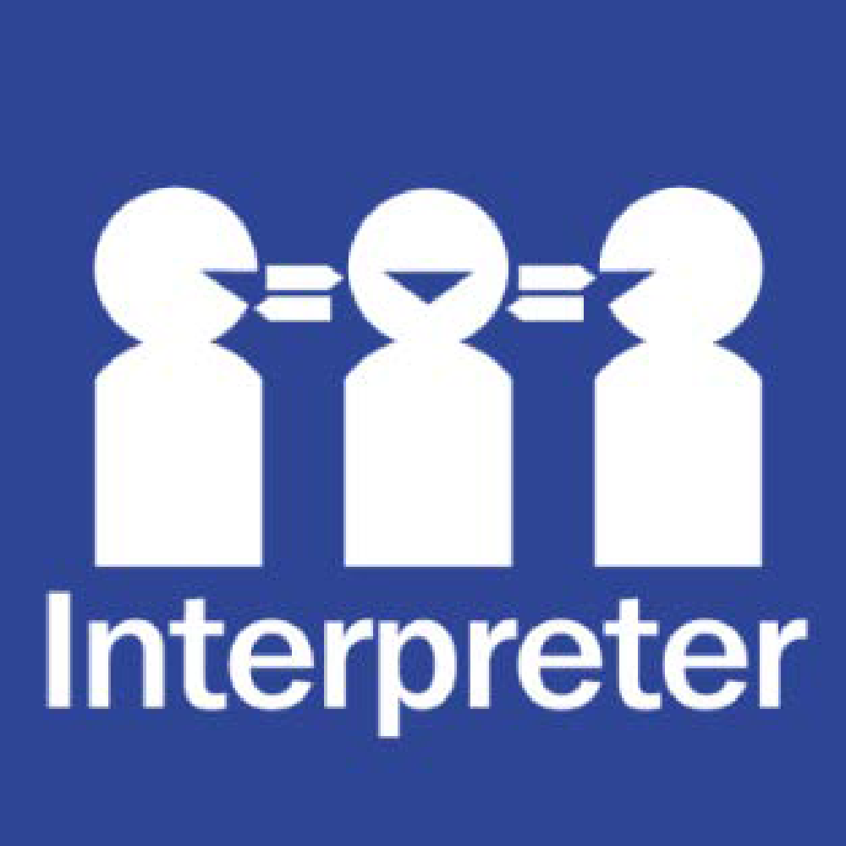
Help for non-English speakers
If you need help to understand the information in this policy, please contact the school office on (03) 9546 9210.

Harrisfield Primary School is guided by the Department of Education guidelines regarding CCTV in Schools.
Policy and Advisory Library | education.vic.gov.au

COMMUNICATION
This policy will be communicated to our school community in the following ways:
- Available publicly on our school’s website where applicable
- Saved on Staff Google drive
- Included in staff induction processes, staff training and child safety training processes
- Discussed at staff briefings/meetings as required
- Discussed at parent information nights/sessions where applicable
- Included as annual reference as a COMPASS notification if required
- Made available in hard copy from school administration upon request.

POLICY REVIEW AND APPROVAL
Policy last reviewed | 10th March 2026
Next scheduled review date | March 2029

