

Harrisfield Primary School
4730
Parent Information Handbook

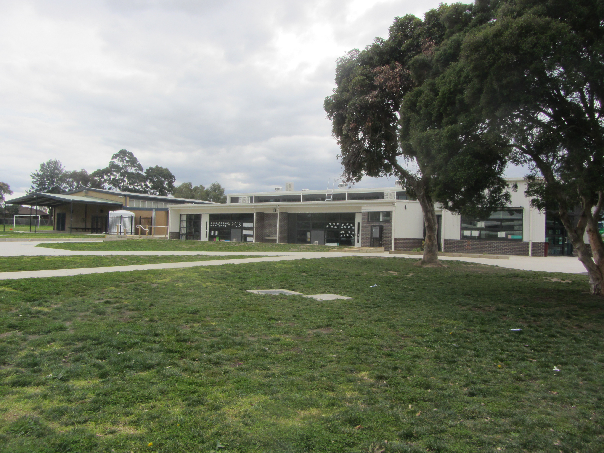

Address: 495 Princes Highway Noble Park 3174
Telephone: (03) 9546 9210
Web: www.harrisfieldps.vic.edu.au
Email: harrisfield.ps@education.vic.gov.au
Principal: Mrs Trish Harry
Assistant Principal: Mr George Tsianakas

VISION STATEMENT

Harrisfield Primary School strives to develop the personal and interpersonal skills of every student to enable them to become active participants in their global community.

Our contribution to their learning journey will build the foundations for them to be innovative thinkers and life- long learners, prepared to face the challenges of an ever changing society.

 linking school  linking home  linking school  linking home 

A

ACE Values
Harrisfield Primary School prides itself on its core values that are encouraged and reinforced constantly. The Whole School Community of students, teachers and parents are encouraged to behave in a manner that supports the values of Agreement, Communication and Equity established by the school. These are outlined in more detail in a handout available at the school office. The Whole School Community is encouraged to adhere to these values and monthly awards are made to students who demonstrate ACE skills consistently.

Our ACE values and expectations are explained in detail on the pages at the beginning of this handbook.

ABSENCES/ATTENDANCES
Computer generated class attendance lists are maintained by all class teachers. Attendance is registered by 9:05 am and 2:30 pm each day. Parents must provide a reason for each absence. The preferred method of reporting your child’s absence is by telephone. You may leave a message at any time of the day or night by selecting the attendance option on the phone. Office staff will keep records of phone messages and pass the information to the class teacher.
Absences can also be submitted via our web page or by emailing the school at harrisfield.ps@education.vic.gov.au
For security purposes, all parents must go through the office when their child leaves or arrives at school outside the regular hours.

ACCIDENTS
Children who are injured or ill are sent - with teacher approval - to the Office for appropriate first aid treatment. Teaching and office staff qualified in Level 2 first aid are on duty at the Office each recess, lunchtime and instruction times.
Parents will be contacted when there is cause for concern, especially with head injuries. Parents may be required to collect the child from school for home care/doctor treatment. Where they cannot be contacted, EMERGENCY CONTACT persons will be contacted.

ADDRESSES and CONTACT DETAILS
Contact details for all students are kept in the office and must be kept up to date. Please notify the office of any changes as soon as possible.

ADMINISTRATION

The Admin team consists of:
Principal: Trish Harry
Assistant Principal: George Tsianakas

Office Administration

General Office: Belinda Hall

ANNUAL REPORT & ANNUAL IMPLEMENTATION PLAN (AR & AIP)
The Department of Education requires each school to complete an Annual Report and Annual Implementation Plan. These documents include information relevant to the school over the year. The report is submitted to School Council and to the Department. Copies are available from the office or on our website www.harrisfieldps.vic.edu.au

ASSEMBLIES
These take place every Friday in the School Hall at 3.00pm. All classes attend. All parents, family and school community members are welcome and encouraged to attend. Our School Student Leaders plan and conduct the assembly. Student Awards, including monthly ACE awards, are given, an item is performed, ACE Values are reinforced and announcements are made. Occasionally guest speakers are invited for a special purpose.

AWARDS

Ace Awards are given every month to one student in each class who has been outstanding in demonstrating the ACE Agreed Values for that month. These students receive an ACE certificate and an ACE badge at Friday’s Assembly. Parents of the children who receive the certificate are invited to attend the Assembly. ACE Values are listed under headings of Agreement, Communication and Equity.

B

BICYCLES/SCOOTERS/SKATEBOARDS
Bicycles, scooters and skateboards cannot be ridden to school or left at school during the school day.

C

CAMPS
Independence and interpersonal skills are nurtured by this program which consists of three-day camp in grades 4-6. All children are encouraged to take part. Camps are considered an essential part of each child’s education. If there are financial concerns please contact the principal. Parents are also invited to assist on camps.

CHEWING GUM

Children are not permitted chewing gum at school.

CHILD SAFE

Harrisfield is a child safe school. Please refer to our website for our policy.

CLASSES
We try to keep class sizes to a minimum. Each year the principal and staff attempt to place each child in a situation which is appropriate to his/her needs. Academic, social, physical and other factors are all taken into consideration.
We believe that the classroom should mirror real life where people of different ages, abilities and talents can work together harmoniously. An inquiry based curriculum, co-operative learning situations, ‘hands on’ activities and multi-age groups are features of the school.

CLASS SUPERVISION
For safety reasons children are not permitted in their classrooms at any time unless a teacher is present.

CONSENT FORMS
These forms are always sent home for approval prior to any school excursion or additional school activity. The forms are also used to record an emergency contact for the day when you do not want to change the permanent contact record at the school.
Consent forms must be signed so that we can take appropriate action if an accident occurs and you or your nominated contact person cannot be reached. Please ensure these forms are returned by the due date.

CELEBRATIONS AT SCHOOL

Each year Harrisfield Primary School celebrates various events. These are outlined below:

Leaders Induction: This is a special Assembly held to induct the new School Captains and School Student Leaders who take on various roles throughout the year.

Junior School Council Induction: A special Assembly is held to induct the two Junior School Councillors from each year level and present them with their badges.

Anzac Day: A special Assembly is held for students and parents to celebrate the achievements and memory of the Australian ANZACs

Remembrance Day: A special Assembly is held to honour the memory of our soldiers who fought to protect our country.

Year 6 Graduation: This is a Dinner and a Presentation to celebrate the achievements of our outgoing Year 6 students at the end of the year.

Harmony Day: Students will participate in activities celebrating many cultures. A whole school dinner is also held after school.

D

DIARY
Students in all grades are required to maintain a school diary to support their organisation and learning. This is also used as a means of communication between home and school and should be checked daily by parents.

DROP OFF AND PICK UP TIMES
We expect children to be punctual in the morning. However drop-off should not occur before 8.45 am as there may not be a staff member on duty to ensure your child’s safety. Normal pick-up time is 3.30 pm, with departure supervised by staff members until 3.45pm. All uncollected students are then brought to the office for pick up by their parents.

E

EARLY LEAVERS
No child is permitted to leave the school during school hours unless accompanied by a parent or adult nominated by the parent. Please contact the school to confirm if any special arrangements need to be made. If you collect your child/ren early, it is important to visit the school office to collect your child.

EATING AREAS
Time should be allocated to enable children to eat in the classroom or seated outside under teacher supervision. Children should be seated if they are eating. This arrangement minimises litter and encourages healthy eating habits.

EMERGENCY CONTACT
No matter how good the care at home or school, children can suffer serious illness or accidents.
We must be able to contact a parent at home or work if an accident occurs at school. Please update telephone numbers, addresses and emergency contacts immediately they change.
If you cannot be contacted during the day, nominate a relative, friend or neighbour. Give our office manager a call on 9546 9210, send a written note with your child, or drop by the office.

ENROLMENT PROCEDURE

Most primary schools start taking enrolments in June each year, for the following year. Children must be five years of age or older by 30 April of the year they start school.
To enrol your child, schools need:
- evidence of your child’s date of birth
- names and addresses of the child and parents, guardians and carers
- parents’ phone numbers (home, work, mobile) and email addresses
- names and contact details of emergency contacts
- doctor’s and dentist’s names and phone numbers
- Immunisation Status Certificate
- health and welfare information (for example, does your child have asthma, diabetes, allergies, poor eyesight or hearing, specific custody arrangements)
- information about the language/s your child speaks and hears (to help the school build on your child's knowledge and appreciate our community’s cultures).
- relevant VISA details, if applicable

F

FIRST AID
Refer to Sick Bay.

FINANCES
The School Council ratifies the allocation of all the funds to programs. The Finance Sub-Committee regularly monitors and reports to council on progress against the budget.

FINANCIAL CONTRIBUTIONS FROM PARENTS
Refer to Books and Materials.

FRUIT SNACK
To support our healthy eating strategy children are encouraged to bring a fruit snack to enjoy throughout the day.

FUNDRAISING
The Fundraising Sub-Committee of School Council coordinates fundraising events for our school. Each year, the fundraising proceeds are allocated to particular projects. Eg: to improve grounds, buy equipment etc.

G

GROUNDS

For the safety of our children the following rules exist during school hours
- Children are to only climb on equipment suitable to their height.
- The car parks are out of bounds
- Children are to walk on pathways and around buildings
- Children are to use bins provided for rubbish
- Children are encouraged to seek assistance from the teacher on duty

H

HEAD LICE
This is a problem which unfortunately occurs in schools everywhere. Please inform the school if your child has been treated for head lice so that a notice can be immediately distributed to parents from that specific grade. Information can be obtained from the office about treatment. Further information can be found at http://www.health.vic.gov.au/headlice/about.htm

HEATING & AIR CONDITIONING
All classrooms are fitted with heating and air conditioning.

HOUSE SYSTEM
Each year, house captains (and vice captains) are selected from the Grade 6 children through popular ballot and teacher input.
Meetings are held as required. All children will be assigned to houses and siblings shall be placed in the same house unless otherwise requested.
There are four houses – Red (Barton), Blue (Chisholm), Green (Deakin) and Yellow (Monash).

I

ILLNESS/ABSENCE
We want punctual, regular attendance; but a sick, unhappy child cannot possibly concentrate on learning and there is also the possibility of infecting other people. The best place for a sick child is home.
If your child is absent for any reason, please contact the school. If you have concerns about such things as mystery stomach aches that only appear on Monday mornings, it may be worth discussing these concerns with your family doctor and your child’s teacher.

INTERPRETERS
These are made available by a government program. Interpreters are available for all interviews required between teachers and families. They are also available for phone calls made between home and school. For enquiries please contact the school Office staff.

L

LATE COMERS
We encourage all children to attend school on time. Parents with latecomers should report to the office before going to class.

LEAVING SCHOOL
Refer to Early Leavers.

LIBRARY
Children are encouraged to use the library. All children may borrow books for up to two weeks. Parents are asked to see books are treated carefully and returned by the due date. Children require a library book bag made from strong material, (about 30 cm wide and 40 cm long) preferably waterproofed and labelled with the child’s name in order to borrow from the school library. If your child misplaces or loses a library book, a note with the cost of a replacement book will be sent home.

LOST PROPERTY
Labelling of all articles of clothing is essential. If lost, the named clothing is easy to return to the child. Lost property is sent to the office for sorting. Parents are encouraged to look through the items on a regular basis. Items not collected after a period of time are sold at second hand prices.

LUNCH
A nutritious, substantial snack is recommended for the morning break at 11:05 am as lunch is not eaten until 1:40 pm. Every effort is made to provide eating time at Recess and Lunch time. Otherwise children eat quietly in the designated eating areas. Children should bring a fruit snack and water bottle which they can also have during the day.

M

MEDICATIONS
Whether in school or on excursions or camps, teachers need to know whether children require certain medicines to maintain their physical wellbeing.
Medical conditions such as diabetes, asthma and serious allergies should be made known and documented so that appropriate action can be taken if problems occur.
Medication can be administered to your child by staff, with your signed authorisation, if you are unable to come to school and give the medication yourself. Contact the office for details.
Children are encouraged to administer the appropriate dosage of asthma medication themselves. This obviously assists the child’s independence and confidence in managing their own symptoms.

MONEY
Any money and notes sent from home should be in an envelope and given to the Office at the beginning of the school day.

N

O

OUT OF BOUNDS AREAS

The following areas are out of bounds:
- The car parks and driveways
- Unattended buildings
- Fences and trees

P

PARENT INTERVIEWS
Parent teacher interviews are held early in the year to ensure teachers have all relevant information about students. Please contact your child’s teacher to arrange other interviews, if required. Alternatively, you will be contacted if there is a need to discuss your child’s progress.

PERSONAL PROPERTY
Personal property is often brought to school by students and visitors. This can include mobile phones, calculators, toys, and sporting equipment. Please note that the Department does not hold insurance for personal property brought to schools and it will generally not pay for any loss or damage to such property. Please consider this carefully if intending to send valuable items with your child to school.

PHOTO POLICY
Parents are only permitted to take photos of children if their own child is the focus of attention.

PLAYGROUND AREAS
Children have access to many suitable playground areas. This includes the school oval, asphalt area and the Junior and Senior playgrounds with specialised play equipment for various ages.

PREP ENTRY

Children starting the school year in Prep, and their parents, are invited to participate in a Transition program in Term 4 where the specific needs for children starting school are addressed.

PUPIL FREE DAYS
The Department determines the number of Pupil Free Days each year. School Council approves when these are taken and for what purpose.

R

RAINY/WET DAYS
Normal school hours continue but if the weather is considered too cold or wet children are supervised within the classrooms during recess and lunchtime. If there is a break in the weather we encourage students to go outside. A suitable waterproof coat or warm jacket is needed in these situations, or for walking to or from home, so please ensure your child comes well prepared.

REPORTS
Students receive progress Reports twice per year – at the end of Terms 2 and 4. Report Interviews for all parents are held after the Term 2 Reports are issued and interpreters are available. An interview is available, if requested, after the Term 4 reports are distributed.

S

SCHOOL COUNCIL
The School Council governs school policy and financial policy. The School Council consists of 15 members, 10 elected non-Department members and 5 elected Department members. The School Council generally meets on the first Monday of each month from 7.00pm in the staffroom. An Annual Reporting Meeting night is held in March each year. The first meeting of each year incorporates elections for half of the council. Councillors are elected for a 2 year term. School council meetings are held at least 8 times a year.

SCHOOL CROSSING
Our school crossing supervisor is provided by the local council under very strict guidelines.
The supervisor is on duty from 8.10 am to 9.10 am and from 3.00 pm – 4.00 pm daily. Please remind children to use the crossing properly. Our school crossings are at the Callander Road entrance and Bowmore Road for those who use our back entrance.

SCHOOL LEADERS
Students from Grade 6 will be elected as School Leaders. The leaders are responsible for various roles such as representing the school at events, school tours, leading assemblies, environmental issues and leading action teams etc.

SCHOOL PHOTOS
Professional Photographers are invited to take school photos of the children. All children are photographed, but it is not compulsory to purchase the photos. Payment envelopes are provided to the children for orders. Notification of the school photos date is via the newsletter.

SCHOOL STRUCTURE
The school is divided into 3 levels– Preps, Juniors and Seniors.

SCHOOL TIMES
We expect children to be punctual so that learning time is used efficiently. Please help your child to start school on time.

8:57 am School commencement warning
9:00 am School commencement/class administration
9:05am-10:05am Period 1
10:05am-11:05am Period 2
11:10am-11:40am Recess
11:40am-12:40pm Period 3
12:40pm-1:40pm Period 4
1:50pm-2:30pm Lunch
2:30pm-3:30pm Period 5

SICK BAY
During the course of a school day it may be deemed necessary for your child to go to sickbay. This may be the result of an accident or because they are feeling unwell. Staff who are on duty in the Sickbay all have Level 2 First Aid qualifications to ensure that children receive appropriate treatment. When a child is deemed well enough, they will be returned to class. If there is any doubt about a child’s wellbeing, parents will be contacted immediately to come and collect their child from school.

STRATEGIC PLAN
This 4 year plan is a commitment by the school council to put into place quality education for all its students. Taking into account Department (DET) policies, the perceived needs of the learning community and the available resources, it provides the framework for ongoing improvement to our school programs. It also indicates the many mechanisms by which we can evaluate those programs and then report to the community on our progress. Copies are always available from the office for your perusal.

SUNSMART
Harrisfield Primary is an accredited SunSmart School. Students are expected to wear broad brimmed or legionnaire hats when participating in outdoor activities in 1st and 3rd terms and on school excursions and camps.

SUPPORT AGENCIES

City Of Greater Dandenong | 8571 1000
Monash Link Community Health Service | 1300 552 509
Monash Link Dental | 1300 654 889
Greater Dandenong Community Health Service | 9792 8100
City Of Greater Dandenong Family Day Care | 8571 1805

SWIMMING
The swimming program encourages safety procedures and skills which enable children to participate with confidence in water activities. Opportunities are given for all children to acquire a reasonable level of swimming competence as well as extension activities for advanced swimmers. Swimming lessons are offered for all students at an indoor heated pool where qualified instructors supervise the children in small groups.

T

TERM DATES

2025
Term 1: 28 January (teachers & staff start) to 4 April
Term 2: 22 April to 4 July
Term 3: 21 July to 19 September
Term 4: 6 October to 19 December

TOILETS
Children are encouraged to use the toilets during recess and lunch breaks. If they need to go during lesson times, they go in groups of three for safety reasons. Please inform the school if your child has a medical condition regarding toileting.

TRAFFIC AND PARKING
Parking areas around Harrisfield are clearly marked and council by-laws officers are often in attendance to ensure that drivers observe parking restrictions. Peak periods pose the most danger, so we ask parents to observe all traffic laws and to drive and park responsibly. Please also obey all parking and clearance times at the school crossings when they are operating.

U

UNIFORMS
Please refer to Uniform Policy and price list is available on the school website www.harrisfieldps.vic.edu.au or from the office. Details or our uniform supplier are detailed below.
Beleza Uniforms
162 Cheltenham Road
Dandenong 3175
Telephone: 9794 8775
We have a limited range of second hand uniform items available from the school. Please see the Office regarding this. Uniform that has been outgrown or no longer used is also gratefully accepted at the Office as well.

V

VISITORS
For the safety of pupils, school policy is that all visitors report to the general office upon entering the school grounds. You will need to fill in the Visitor’s Book upon arrival and leaving. This is located on the front desk. The office staff will issue a visitor badge.
On departure, please return badge to front office and sign out.

VOLUNTEERS
Refer to – Working With Children Check

W

WELL BEING
Our Well Being team consists of our Well Being Officer, Speech Pathologist and School Psychologist. If you would like to contact any of these people please call the office to make an appointment.

WORKING WITH CHILDREN CHECK
The Department of Justice require parents wishing to volunteer at school, help out in classrooms or attend excursions to have a current Working With Children Check. Applications are available at Australia Post outlets or you can also apply online at www.workingwithchildren.vic.gov.au

Y

YARD DUTY
The yard duty teacher wears a fluoro vest and also carries a backpack with basic first aid supplies. This identifies the teacher on duty for the children & enables incidents to be recorded and minor cuts, grazes to be handled ‘on the spot’.
Two teachers are on duty at before school, recess and lunchtime. The Principal & Assistant Principal undertake after school duty. Please note staff do not supervise the yard before 8.45am and after 3.45pm.

